Lab 2

Josh Bailey

**Exercise 1**

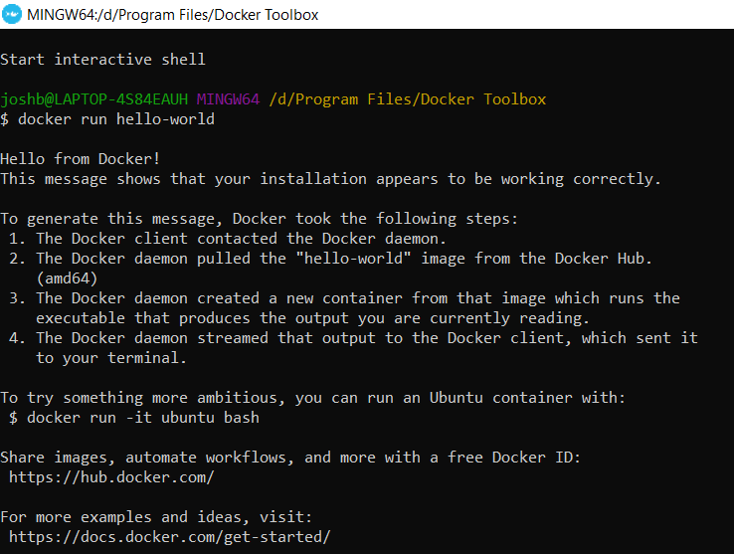

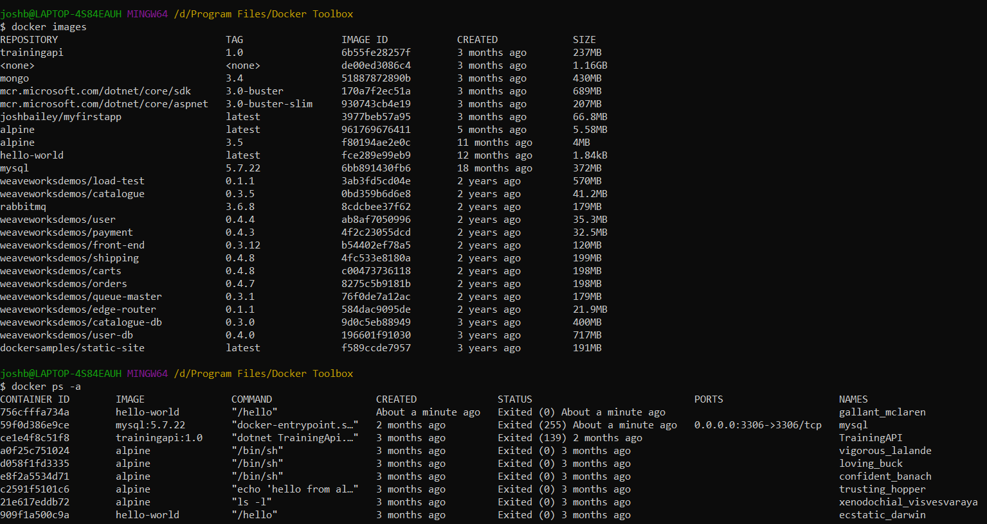

**Exercise 2**

**1.**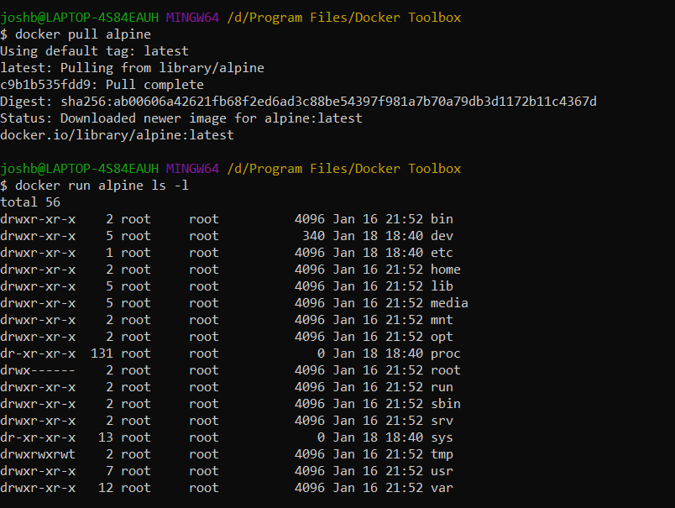

**2.**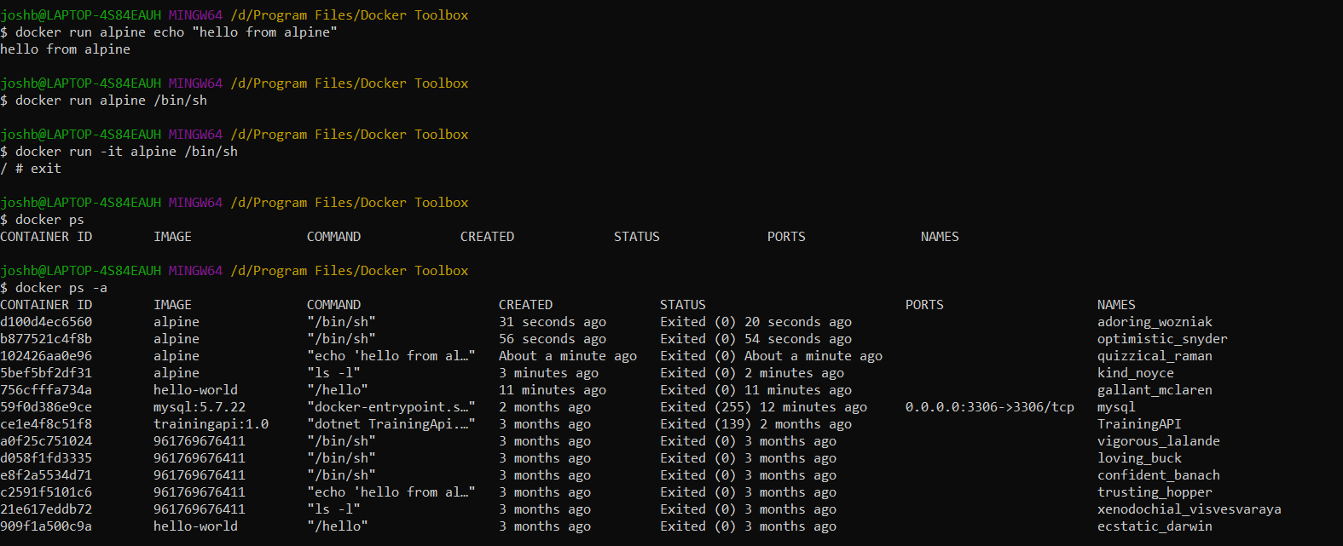

**3.**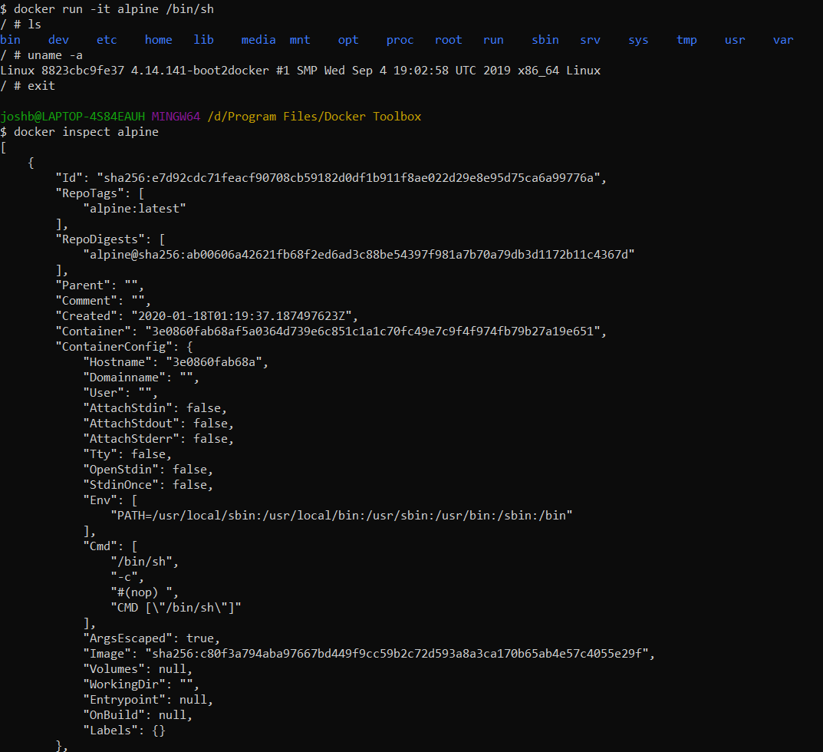

**Exercise 3**

**1.**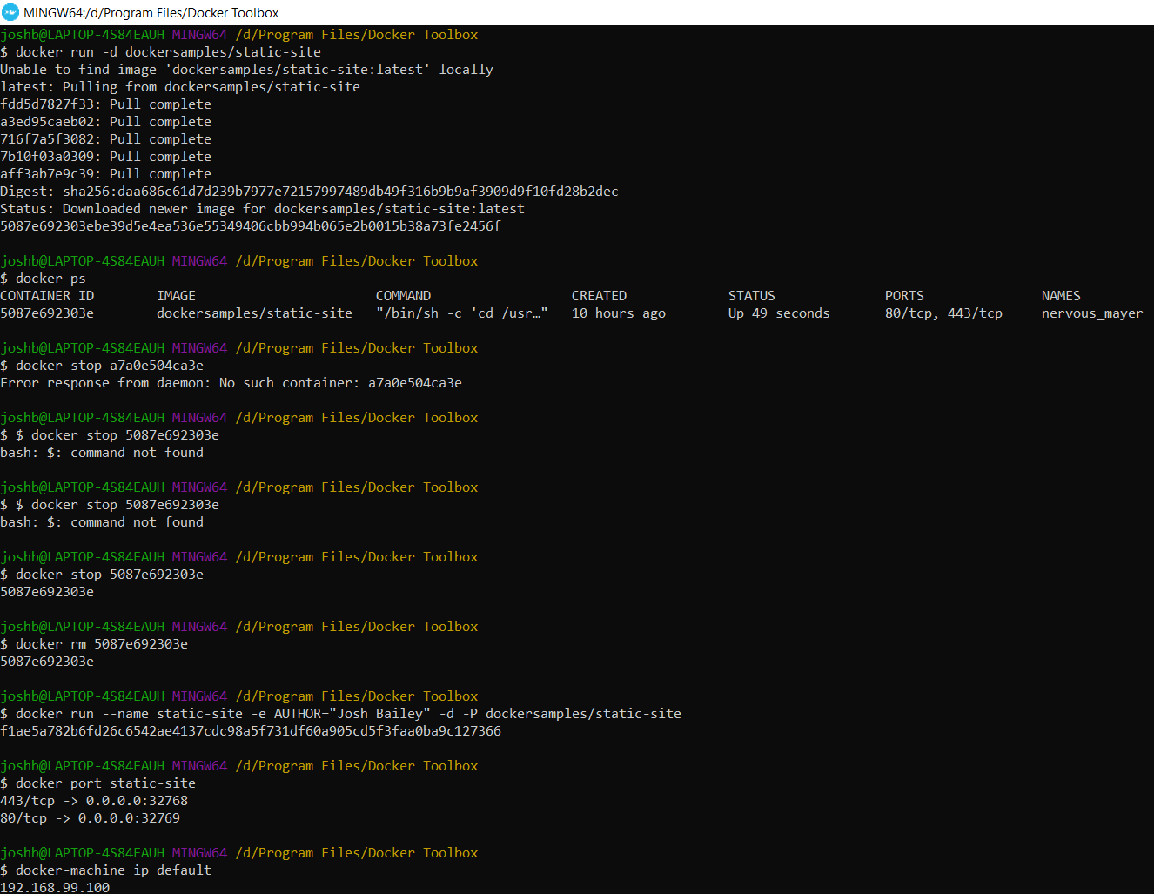

**2.**

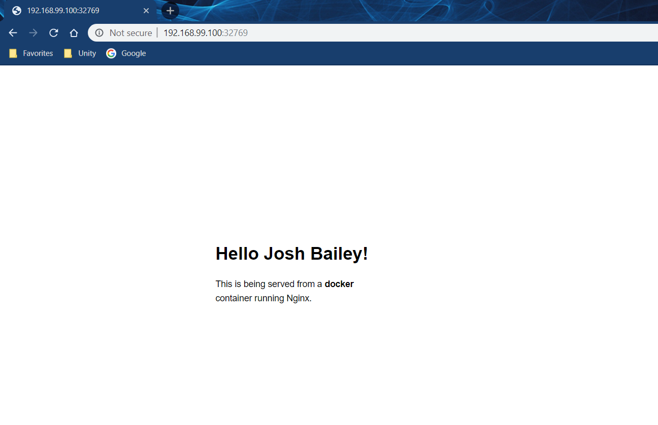

**3.**

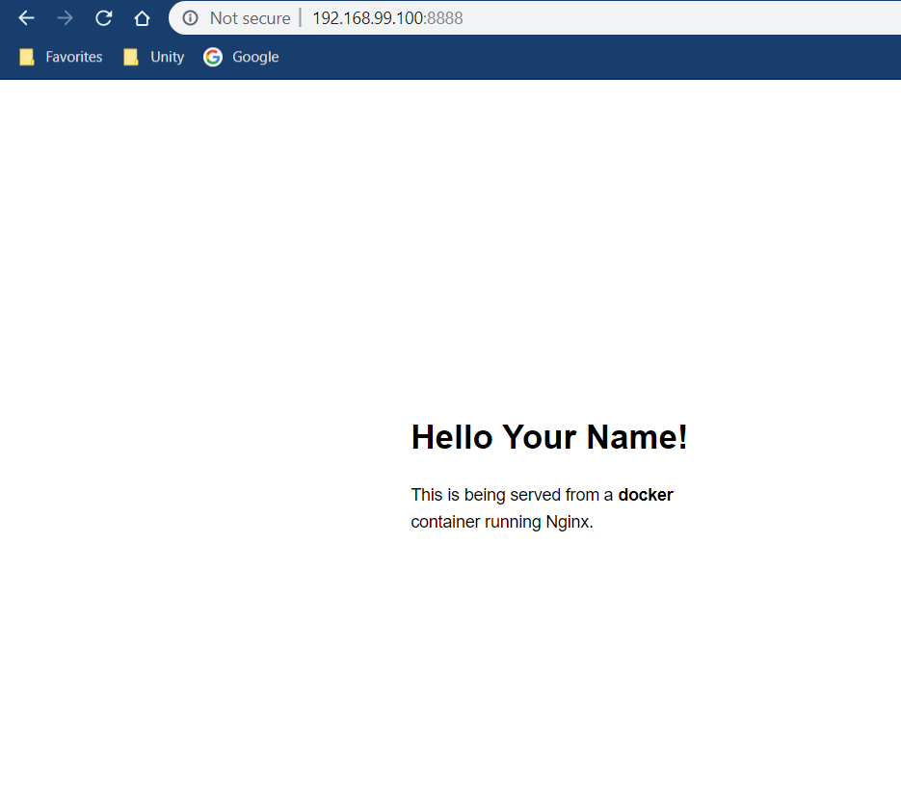

**4.**

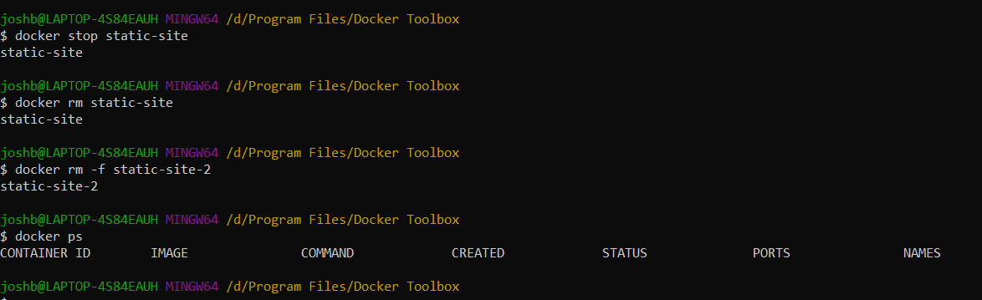

**5.**

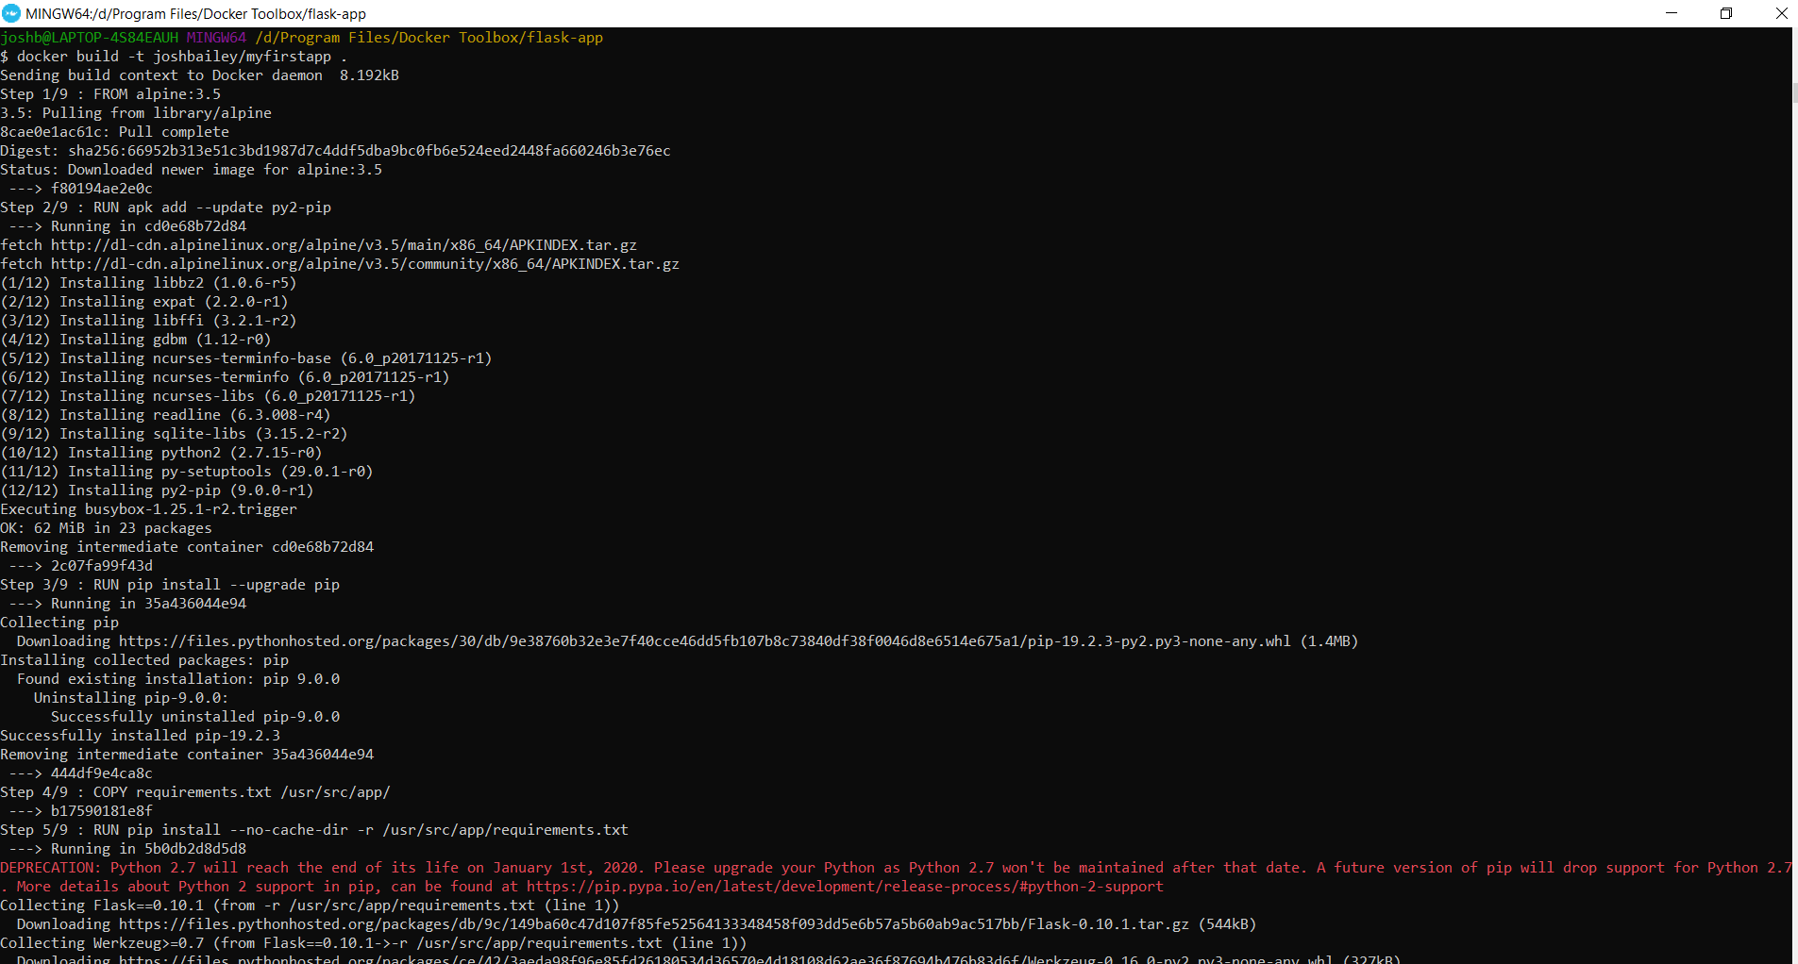

**6.**

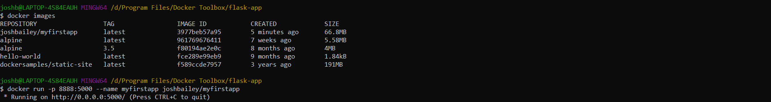

**7.**

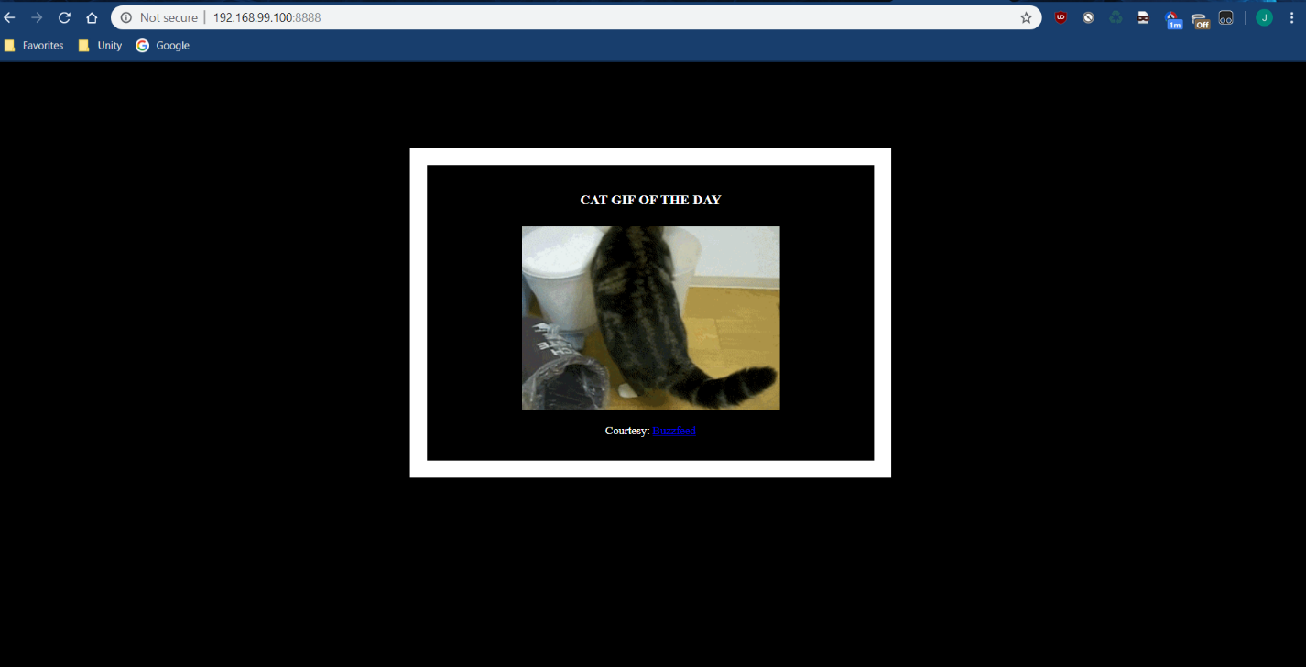

**8.**

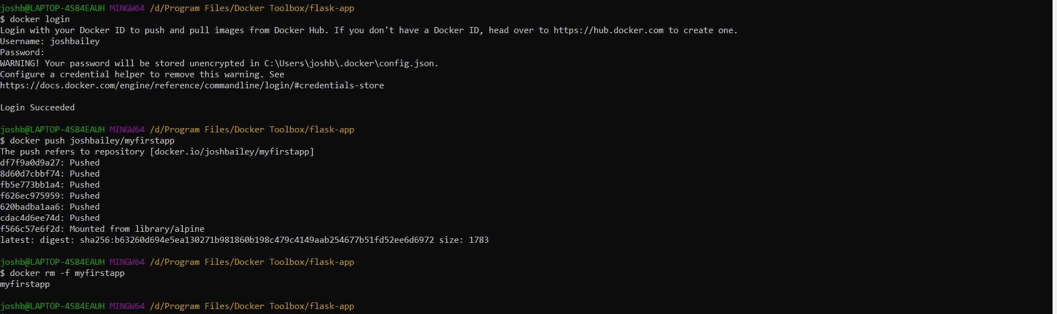

**Exercise 4**

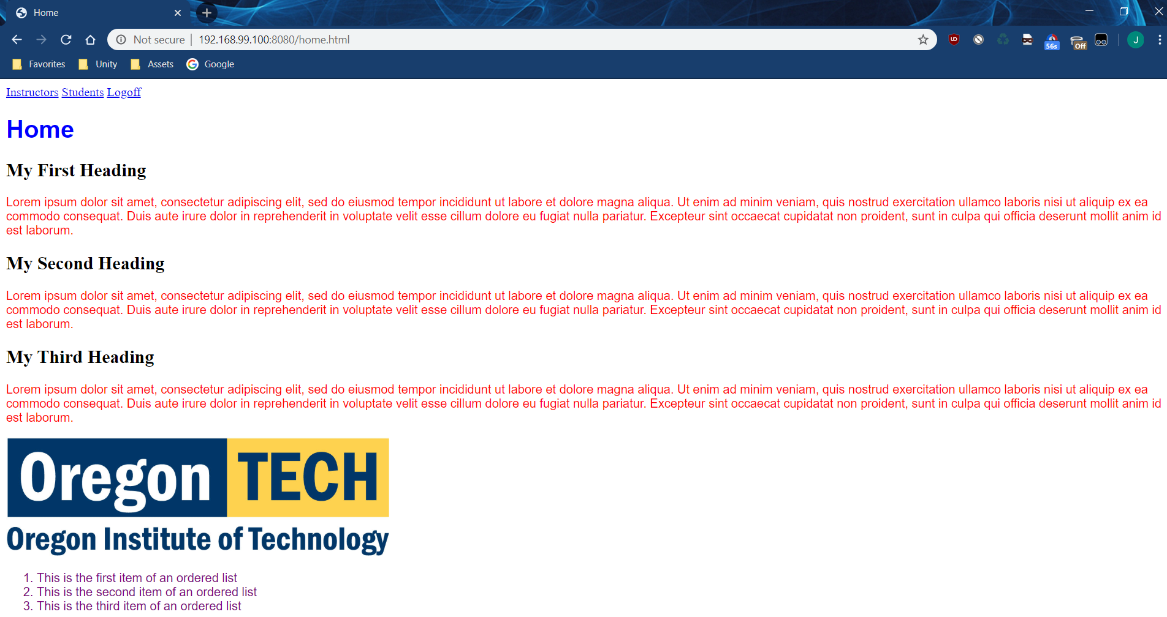

Link to Dockerhub: <https://hub.docker.com/repository/docker/joshbailey/webdesignapp>